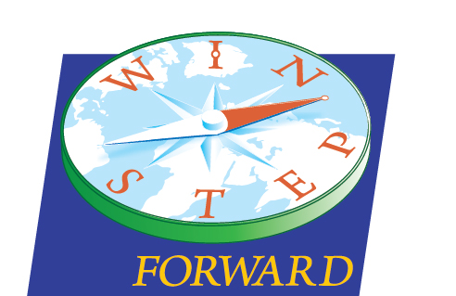
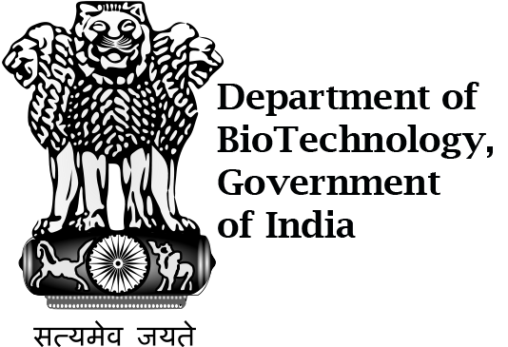

Khorana Bose Orientation Agenda
Location: | 440 Henry Mall, Madison WI 53706
Date: | May 21st
Time: | 8:00AM – 9:00PM
Facilitators: | Aseem Ansari, Naveeda Qadir, Eric Horn, Lexi Frerks

Agenda items
[8:00AM] — [8:30AM] | [Breakfast]  We will provide a breakfast in the dorms for scholars, but promptly at 8:30AM we will head over to Engineering Hall | [Jorns Hall]
[9:00AM] — [10:00AM] | [Speakers]  9:15 - 9:30 Associate Dean for Graduate Education Parmesh Ramanathan  9:30 - 9:45 Dean of Engineering Jack Russell  9:45 - 10:00 WINStep | [Engineering Hall Room 1610]
[10:00AM] — [11:00AM] | [Group Activity]  Logo Design for T-Shirts | [Engineering Hall Room 1610]
[11:15AM] — [12:15PM] | [Speakers]  10:45-11:00 Khorana Bose Alumni  11:00-11:15 Khorana Bose Panel  11:15 - 11:30 Geeta Brown University  11:30-11:45 Speaker (Shravan?)  11:45-11:50 Ken Shapiro | [Engineering Hall Room 1610]
[12:30PM] — [2:00PM] | [Lunch]  Catered by Swagath | [Engineering Hall]
[2:00] — [2:30PM] | [Speakers]  2:00-2:15 SCI-ROI – Piyush  2:15-2:30 Sci-ROI Panel | [Engineering Hall Room 1610]
[2:30PM] — [3:00PM] | [Group Activity] | [Engineering Hall Room 1610]
[3:00PM] — [4:00PM] | [Speakers]  3:00-3:15 Sadhana Srivastava - ICMR-  Tech Transfer in India  3:15 - 3:30 Guna/Anjali/Giri  3:30-3:45 Epic  3:45- 4:00 Aseem Ansari | [Engineering Hall Room 1610]
[4:00PM] — [5:00PM] | [Break]  Here you can return to your dorms and change clothes if you wish | [Dorm]
[5:00PM] — [6:00PM] | [Make way to State Capitol]  Here we will all take a photo, go inside? | [2 E Main St, Madison, WI]
[6:30PM] — [7:30PM] | [Dinner]  Grab something from one of the many restaurants along State Street | [State Street]
[7:30PM] — [9:00PM] | [Meet at terrace]  Here we can watch the sunset and continue further community building | [800 Langdon St, Madison, WI]

Additional information
We would suggest bringing a sweater or light jacket for the terrace, it might be a chilly walk home after

